**Information on parking fees in area Strijp S, Eindhoven**

**Short-term parking fees in Strijp S 2022**

Regular short-term parking fee on the street per hour **€ 2.50

Regular short-term parking fee, sites and garages per hour*** €2.50

Regular daily fee (only behind barrier) p/day € 12.25

**The fee for parking on the street will be €1.25 for the first hour because the first half hour is free and €2.50 for each additional hour. There is no maximum fare on the street.

*** Behind the barrier (yards and garages) the parking fee is € 2.50 per hour up to the maximum daily fee of € 12.25.

**Cheapest parking garage** in the area: <http://www.parkingphilipsstadion.nl>. Adress: Gerard Philipslaan, 5616 LX Eindhoven. It is about 650 meters walk to atelier de Olifant

Costs per hour: € 2.00

Below is the walking route:

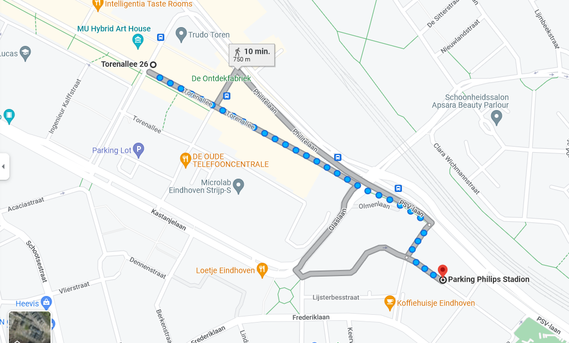

**Free parking** is in Clara Wichmannstraat. It is about 650 meters walking to atelier de Olifant.

Below is the walking route:

