**ROUTE DESCRIPTION Atelier de Olifant, Torenallee 26, 2nd floor, no 48, Eindhoven**

Do you drive via Google Maps? Then enter **'Kastanjelaan Parking**' or **'Parking Lot Kastanjelaan**' and follow the navigation. If it is full, continue to 'Parkeergarage Om De Hoek'.

Do you not drive via google maps or with an older navigation? Then use the route description below with pictures.

● Enter Kastanjelaan in Eindhoven in the navigation.

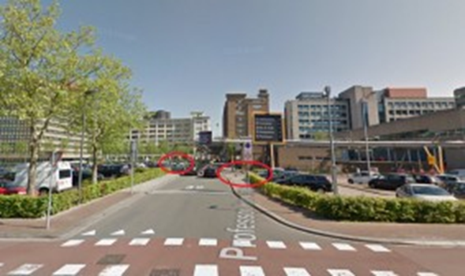

● Halfway through Kastanjelaan, turn onto Professor Horowitzstraat, Eindhoven (turn right from the center and left from the highway). This can be recognized by the traffic signs and road markings that indicate that this concerns a 30-zone.

● Almost immediately after Professor Horowitzstraat, you can turn right (Kastanjelaan car park) or a few meters further left (Torenallee car park), both parking spaces have barriers for both entry and exit.

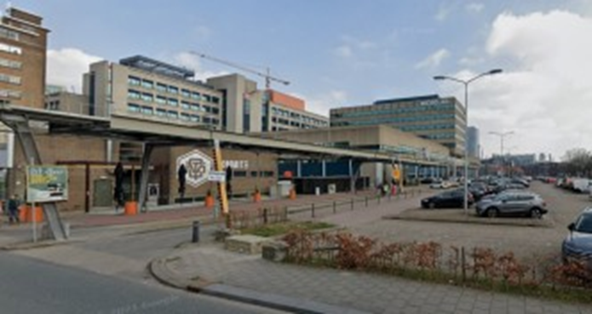

†

**Walking route from parking lot: 'Kastanjelaan'**

● Leave the parking lot through the barriers you entered.

● Follow the pipes above Professor Horowitzstraat for +/- 75 meters.

● Turn left on Torenallee.

● Walk past de Ontdek fabriek.

● The entrance to the Apparatenfabriek is at the end of this building, Atelier De Olifant is on the second floor.

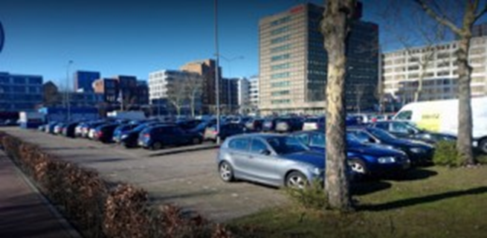

**Walking route from the car park: 'Parking Lot Kastanjelaan'**

● Walk to the left corner of the parking lot (towards the high Bosch building), here you can leave the parking lot uphill.

● Immediately cross the street and walk straight ahead (with the bus lane on your left) until you see the Apparatenfabriek. Atelier de Olifant is located on the second floor.

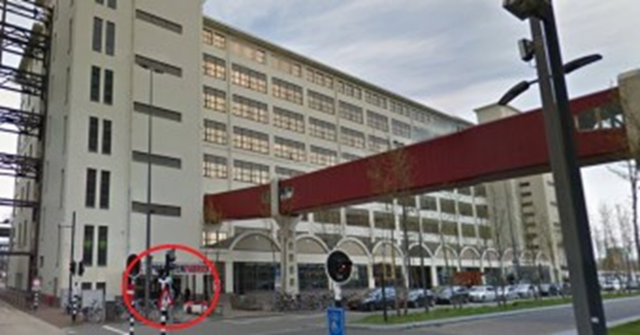

**Are these parking spaces full? Continue to 'Om de Hoek'.**

● Continue down Professor Horowitzstraat until, after a small bend in the road, you reach a large intersection through which a bus lane runs.

● Cross the bus lane and turn left onto Philitelaan.

● Continue straight on Philitelaan until you come to a new intersection.

● Turn right. Parking garage 'Om De Hoek' is indicated.

● Turn right, drive to the end and turn right again, you will enter the covered parking garage. (See next page for image)

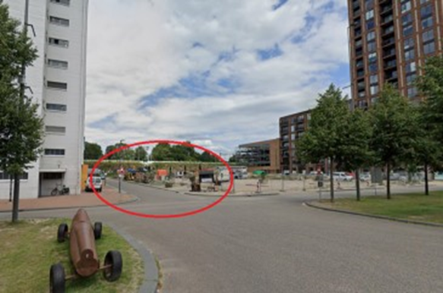

**Walking route from the 'Om de Hoek' parking garage**

● Cross the Philitelaan straight towards the white buildings with high windows. On your right you will see a large square and several large containers.

● Keep the containers on your right and walk under the iron installation that connects the white buildings with large windows. Keep left.

● Immediately left around the corner you will find the entrance. ‘De Apparatenfabriek ‘ is written above the entrance. Atelier De Olifant is located on the second floor.

**Public transport from Eindhoven Central Station**

● Take bus 401, 402 or 403 in the direction of Eindhoven Airport or Veldhoven.

● After about five minutes you will arrive at the Strijp-S stop, get off here.

● Walk in the direction of the bus under the old footbridges.

● Cross the bus lane and you will find the entrance of Atelier de Olifant (Apparatenfabriek) immediately on your left.

**On foot from Strijp-S . trainstation**

● Walk out of the station, cross the main road (Beukenlaan).

● Walk past the Klokgebouw (big blue clock on top of the building) and the Popei eatery.

● Turn left around the building, you are now walking on the Philitelaan.

● Cross the Philitelaan towards the white buildings with high windows. On your right you will see a large square and several large containers.

● Keep the containers on your right, walk around the containers.

● Walk under the old walkways that connect the white buildings. Keep left.

● Immediately left around the corner you will find the entrance.

● ‘De Apparatenfabriek’ is written above the entrance. Atelier de Olifant is located on the second floor.

For guidance advice, please give us a call, we will be happy to help you!

**Phone. 06-41592499**

**Atelier de Olifant Strijp-S**

Torenallee 26 "Apparaten fabriek"

5617 BD Eindhoven